Kensei Project – Task Creation Instructions

Overview
All participants who have selected the Kensei Project are required to create one complete task.
The task must be created based on the assigned persona provided in the shared sheet. Here is the sheet link: Assigned Personas
Here are the personas: Personas Drive Link
Please review the assigned persona carefully and design one task aligned with that persona.
Refer to the provided Kensei project documentation while creating the task.

Task Requirements
Your task must include:
- A complete task based on the assigned persona
- Traps integrated into the task
- Distractor APIs included within the task design
- Task complexity designed to make the model struggle
- Target failure ratio: 40%
The objective is to create a task that meaningfully challenges the model while remaining valid and complete.

Task Classification Rules
You must use only the categories and subcategories listed below.
L1 | L2
Visual Learning | Homework/Problem Solving
Visual Learning | Lab/Fieldwork Documentation
Visual Learning | Textbook/Lecture Comprehension
Commerce & Product | Visual Shopping/Comparison
Commerce & Product | Product Listing QA
Commerce & Product | Brand/Packaging Audit
Creative & Media | Image/Video Editing
Creative & Media | Social Media Content Audit
Creative & Media | Design/Portfolio Review
Operations & QA | Document/Receipt Processing
Operations & QA | Inventory Visual Audit
Operations & QA | UI/UX Screenshot Audit / Form Filling
Health & Wellness | Skin/Symptom Triage
Health & Wellness | Nutrition/Meal Logging
Property & Space | Real Estate Listing Review
Property & Space | Interior Design / Renovation
No categories outside this list are allowed.

Submission Format
Create and submit the task using the provided file format/template image.
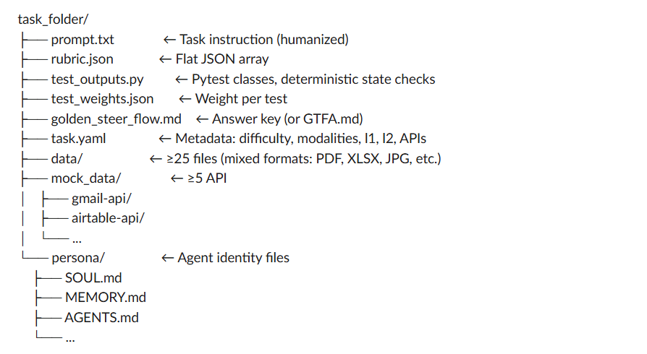
Follow the format exactly.

Folder Naming Convention
Name your folder using the format:
yourname_personaname
Example:
mohit_edward_gordon

Submission Instructions
- Create and complete your task.
- Save all required files inside the correctly named folder.
- Upload the entire folder to a public GitHub repository under your own GitHub profile.
- Ensure the repository is publicly accessible and all files are uploaded correctly.
- Copy the repository URL.
- Submit the GitHub repository link in the provided form:
https://forms.gle/1rYn1h2BWDXs5Dqz5

Important Notes
- Submit only your own task.
- Duplicate submissions are not allowed.
- Any duplicate work may result in strict action, including termination.
- Ensure all required sections are completed before submission.

